

**NATIONAL INSTITUTE OF TECHNOLOGY**

**WARANGAL**

**Department of Computer Science and Engineering**

**B.Tech-II year,II Semester**

**DBMS(2020-2021)**

**DATABASE PROJECT**

**FOOD DELIVERY DATABASE SYSTEM**

**Faculty**

T.Ramakrishnudu

**Submitted by**

P.Rithin (197260)

V.Ankit Reddy (197186)

K.Akash (197245)

1. **PROBLEM DEFINITION :**

The proposed system is an online food ordering system that enables ease for the customers to overcome the disadvantages of the traditional queuing system.The online food ordering system sets up a food menu online and customers can easily place the order as per their wish. Also with a food menu, customers can easily track the orders. This system also provides a feedback system in which user can rate the food items. Also, the proposed system can recommend hotels, food, based on the ratings given by the user. The payment can be made online or pay-on-delivery system. For more secured ordering separate accounts are maintained for each user by providing them an ID and a password.

1. **ASSUMPTIONS :**

* A restaurant can have many items and same item may be in many restaurants .Hence it is M:N relationship.
* A customer can have more than one payment method and many customers can have same payment method. Hence it is an M:N relationship.
* A customer can place many orders while an order is placed by only one customer. Hence it is a 1:N relationship and total participation from orders.
* An order can be paid by only one payment method while a payment method can be used to pay many order. Hence there is a N:1 relationship and there is a total participation from payment methods.
* When an order is placed it has a stages i.e at what time is it placed, at what time the the order is accepted/rejected by the restaurant, at what time the order is picked up by the delivery boy and at what time is it delivered.Hence it is in 1:N relationship and total participation from order_status.
* A order may have many items and same item can be involved in many orders .Hence it is a M:N relationship . Since every order should have atleast one items there is total participation from orders.
* Every ordered item may/may not have a rating corresponding to that order while if an ordered item has rating it must be associated with atleast one order .Hence it is a M:N relationship with items_rating .Since every order and every ordered item may not having a rating there can’t be total participation from either side.
* A delivery boy can deliver many orders while an order can be delivered by only one delivery boy .Hence it is a N:1 relationship.If an order is not placed/rejected due to any reason then an order can’t have a delivery boy .Hence there can’t be total participation from orders.
* Every order delivered by delivery boy may/may not have a rating corresponding to that order while every delivery rating will have only one order associated with it. Hence there is 1:1 relationship.Since every order may not have a delivery rating there is no participation from orders.
* A delivery boy may have many delivery ratings while a delivery rating is associated with only one customer. Hence it is 1:N relationship . Since every delivery boy may not have rating it can’t be total participation from delivery boy.
* Customer can order only from one restaurant at once but each restaurant can be involved in multiple orders (N :1). Since every customer may not rate the restaurant there wont be total participation from orders .
* Customer can apply only one coupon per order but a coupon can be applied on multiple orders if it is applicable (1:N) . A coupon can be available for multiple restaurants and a restaurant can have multiple offers (M:N) .Since every customer may not apply a coupon there wont be total participation from coupons to orders .
* Location table stores the locality for every pincode which will be referenced from restaurant and orders entities . As many restaurants and delivery addresses can have same pincode it will be many to one relationship .

1. **ER DIAGRAM:**

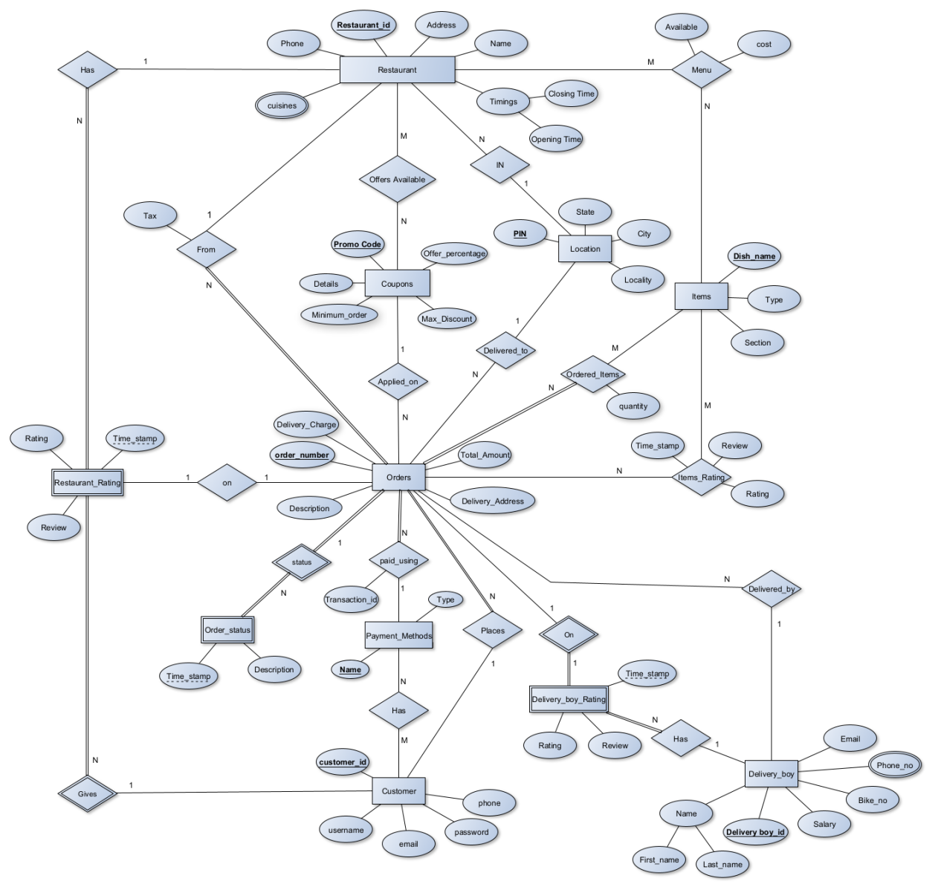

1. **RELATIONAL MODEL :**

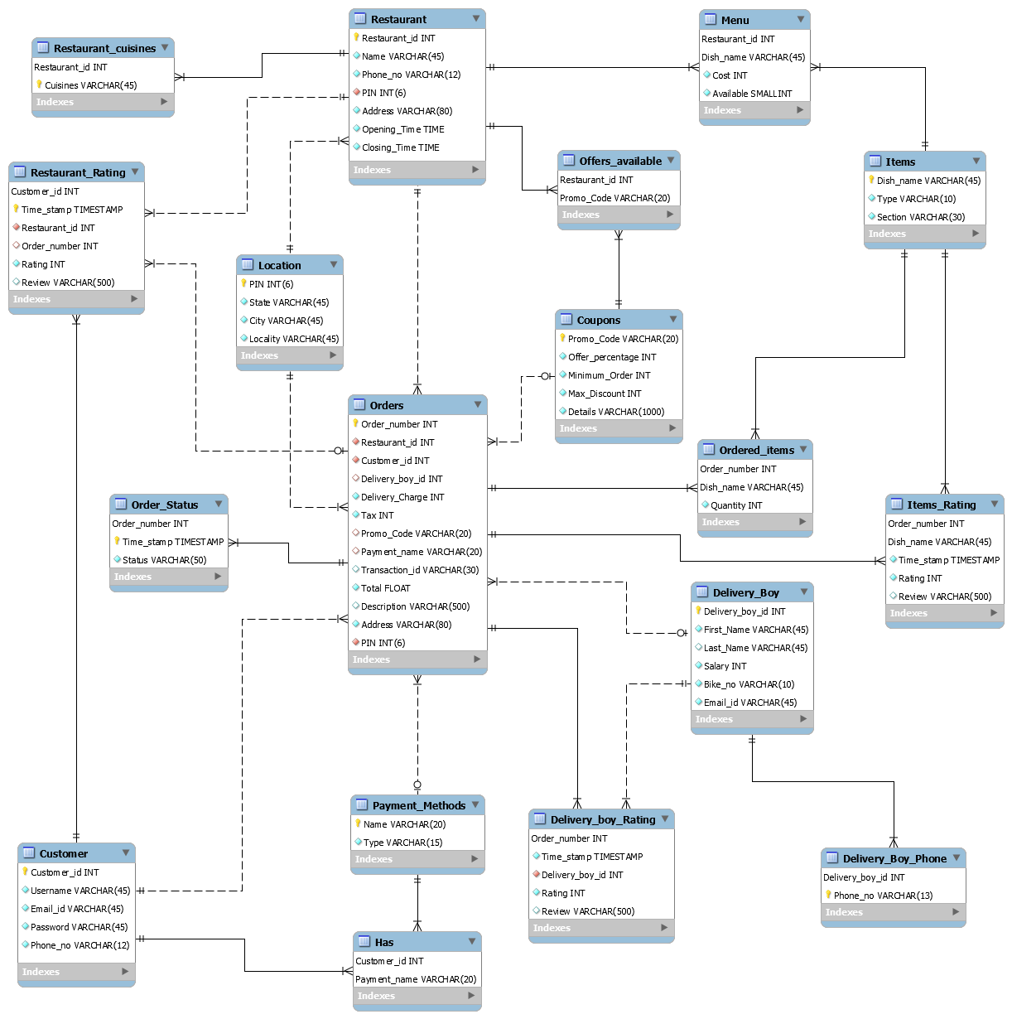

DD 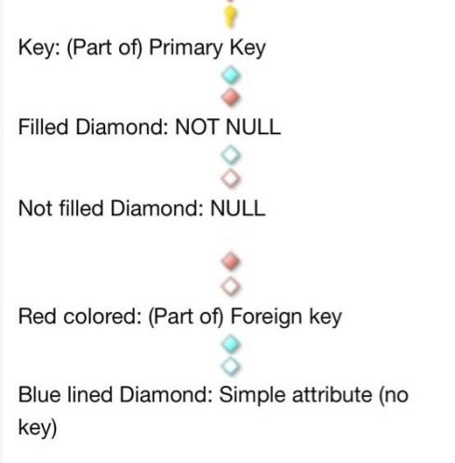 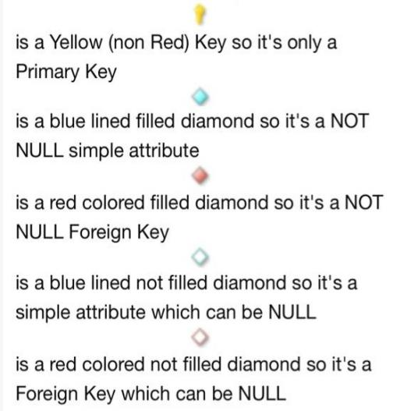

* **O** → The side of the relationship is not mandatory , meaning the field can be null .
* **||** → The side of the relationship is mandatory , meaning the field cannot be null .
* **No Icon** → Attribute is a foreign key as well as part of primary key

1. **FD’s & NORMALIZATION :**

**NOTE :** Below mentioned dependencies are not the only functional dependencies possible i.e by considering Reflexivity rule X→X dependency is possible and by using Decomposition Rule

(if X→YZ then X→Y and X→Z) several other dependencies are possible for each table

**RESTAURANT :**

(Restaurant_id) → (Name, Phone_no, Address, PIN, Opening_time, Closing_time)

(Phone_no) → (Name, Restaurant_id, Address, PIN, Opening_time, Closing_time)

(Address, PIN) → (Name, Phone, Opening_time, Closing_time)

* Candidate keys are Restaurant_id , Phone_no , (Address, PIN)
* Primary key is Restaurant_id
* All the non-prime attributes completely depend on candidate keys .Hence the relation is in 2NF.
* All the non-prime attributes are not transitively dependent on any key of the table. Hence the relation is in 3NF.
* All the determinants are candidate keys.Hence the table is in BCNF .

**RESTAURANT_CUISINES :**

(Restaurant_id,Cuisines) → (Restaurant_id,Cuisines)

* Primary key is (Restaurant_id,Cuisines)
* Since there are no non-prime attributes , table will be in 3NF .
* All the determinants are candidate keys.Hence the table is in BCNF.

**RESTAURANT_RATING :**

(Customer_id, Time_stamp) → (Restaurant_id, Order_number, Rating, Review)

(Order_number) → (Restaurant_id, Customer_id, Time_stamp, Rating, Review)

* Candidate keys are (Customer_id, Time_stamp) , Order_number
* Primary key is Order_number
* All the non-prime attributes are completely dependent on candidate keys .Hence the relation is in 2NF.
* All the non-prime attributes are not transitively dependent on any key of the table. Hence the relation is in 3NF.
* All the determinants are candidate keys.Hence the table is in BCNF .

**CUSTOMERS :**

(Customer_id) → (Username, Email_id, Password, Phone_no)

(Email_id) → (Username, Customer_id, Password, Phone_no)

(Phone_no) → (Username, Email_id, Password, Customer_id)

* Candidate key are Customer_id , Phone_no , Email_id
* Primary key is Customer_id
* All the non-prime attributes completely depend on candidate keys .Hence the relation is in 2NF.
* All the non-prime attributes are not transitively dependent on any key of the table. Hence the relation is in 3NF.
* All the determinants are candidate keys.Hence the table is in BCNF .

**DELIVERY_BOY :**

(Delivery_boy_id) → (First_Name,Last_Name, Salary, Bike_no, Email_id)

(Bike_no) → (First_Name,Last_Name, Salary, Delivery_boy_id, Email_id)

(Email_id) → (First_Name,Last_Name, Salary, Bike_no, Delivery_boy_id)

* Candidate key are Delivery_boy_id , Bike_no , Email_id
* Primary key is Delivery_boy_id
* All the non-prime attributes completely depend on candidate keys .Hence the relation is in 2NF.
* All the non-prime attributes are not transitively dependent on any key of the table. Hence the relation is in 3NF.
* All the determinants are candidate keys.Hence the table is in BCNF .

**DELIVERY_BOY_RATING :**

(Order_number) → (Time_stamp, Delivery_boy_id, Rating, Review)

* Primary key is Order_number
* All the non-prime attributes completely depend on candidate keys .Hence the relation is in 2NF.
* All the non-prime attributes are not transitively dependent on any key of the table. Hence the relation is in 3NF.
* All the determinants are candidate keys.Hence the table is in BCNF .

**DELIVERY_BOY_PHONE :**

(Deliver_boy_id,Phone_no)→ (Deliver_boy_id,Phone_no)

* Primary key is (Deliver_boy_id,Phone_no)
* Since there are no non-prime attributes , table will be in 3NF .
* All the determinants are candidate keys.Hence the table is in BCNF .

**COUPONS :**

(Promo_Code) → (Offer_percentage, Minimum_Order, Max_Discount, Details)

* Primary key is Promo_Code
* All the non-prime attributes completely depend on candidate keys .Hence the relation is in 2NF.
* All the non-prime attributes are not transitively dependent on any key of the table. Hence the relation is in 3NF.
* All the determinants are candidate keys.Hence the table is in BCNF .

**ITEMS :**

(Dish_name) → (Type,Section)

* Primary key is Dish_name
* All the non-prime attributes completely depend on candidate keys .Hence the relation is in 2NF.
* All the non-prime attributes are not transitively dependent on any key of the table. Hence the relation is in 3NF.
* All the determinants are candidate keys.Hence the table is in BCNF .

**ORDERS :**

(Order_number) → ( Restaurant_id, Customer_id, Delivery_boy_id, Delivery_Charge , Tax, Promo_Code, Payment_name, Transaction_id, Total, Description, Address, Pin )

* Primary key is Order Number
* All the non-prime attributes completely depend on candidate keys .Hence the relation is in 2NF.
* All the non-prime attributes are not transitively dependent on any key of the table. Hence the relation is in 3NF.
* All the determinants are candidate keys.Hence the table is in BCNF .

**LOCATION :**

(Pin) → (Locality , City , State)

* Primary key is Pin
* All the non-prime attributes completely depend on candidate keys .Hence the relation is in 2NF.
* All the non-prime attributes are not transitively dependent on any key of the table. Hence the relation is in 3NF.
* All the determinants are candidate keys.Hence the table is in BCNF .

**ORDERED_ITEMS :**

(Order_number, Dish_name) → (Quantity)

* Primary key is (Order_number, Dish_name)
* All the non-prime attributes completely depend on candidate keys .Hence the relation is in 2NF.
* All the non-prime attributes are not transitively dependent on any key of the table. Hence the relation is in 3NF.
* All the determinants are candidate keys.Hence the table is in BCNF .

**ITEMS_RATING :**

(Order_number, Dish_name) → (Time_stamp, Rating, Review)

* Primary key is (Order_number, Dish_name)
* All the non-prime attributes completely depend on candidate keys .Hence the relation is in 2NF.
* All the non-prime attributes are not transitively dependent on any key of the table. Hence the relation is in 3NF.
* All the determinants are candidate keys.Hence the table is in BCNF .

**MENU :**

(Restaurant_id, Dish_name) → (Cost , Available)

* Primary key is (Restaurant_id, Dish_name)
* All the non-prime attributes completely depend on candidate keys .Hence the relation is in 2NF.
* All the non-prime attributes are not transitively dependent on any key of the table. Hence the relation is in 3NF.
* All the determinants are candidate keys.Hence the table is in BCNF.

**OFFERS_AVAILABLE :**

(Restaurant_id, Promo_Code) → (Restaurant_id, Promo_Code)

* Since there are no non-prime attributes , table will be in 3NF .
* All the determinants are candidate keys.Hence the table is in BCNF .

**PAYMENT METHODS :**

(Name) → (Type)

* Primary key is Name
* All the non-prime attributes completely depend on candidate keys .Hence the relation is in 2NF.
* All the non-prime attributes are not transitively dependent on any key of the table. Hence the relation is in 3NF.
* All the determinants are candidate keys.Hence the table is in BCNF .

**HAS :**

(Customer_id,Payment_name) → (Customer_id,Payment_name)

* Since there are no non-prime attributes , table will be in 3NF .
* All the determinants are candidate keys.Hence the table is in BCNF .

**ORDER_STATUS :**

(Order_number,Time_stamp) → (Order_number,Time_stamp)

* Primary key is (Order_number,Time_stamp)
* Since there are no non-prime attributes , table will be in 3NF .
* All the determinants are candidate keys.Hence the table is in BCNF .

1. **SQL CODE :**

CREATE TABLE LOCATION_(

PIN NUMBER(6) PRIMARY KEY,

State_ VARCHAR(45),

City VARCHAR(45),

Locality VARCHAR(45)

);

CREATE TABLE RESTAURANT(

Restaurant_id INT PRIMARY KEY,

Name_ VARCHAR(45) NOT NULL,

Phone_no VARCHAR(12) NOT NULL,

PIN NUMBER(6) NOT NULL,

Address VARCHAR(80) NOT NULL,

Opening_Time TIMESTAMP WITH LOCAL TIME ZONE,

Closing_Time TIMESTAMP WITH LOCAL TIME ZONE,

FOREIGN KEY (PIN) REFERENCES LOCATION_(PIN)

);

CREATE TABLE RESTAURANT_CUISINES(

Restaurant_id INT,

Cuisines VARCHAR(45) NOT NULL,

FOREIGN KEY (Restaurant_id) REFERENCES RESTAURANT(Restaurant_id),

PRIMARY KEY(Restaurant_id,Cuisines)

);

CREATE TABLE COUPONS(

Promo_Code VARCHAR(20) PRIMARY KEY,

Offer_percentage INT NOT NULL,

Minimum_Order INT NOT NULL,

Max_Discount INT NOT NULL,

Details VARCHAR(1000)

);

CREATE TABLE OFFERS_AVAILABLE(

Restaurant_id INT,

Promo_Code VARCHAR(20),

FOREIGN KEY (Restaurant_id) REFERENCES RESTAURANT(Restaurant_id),

FOREIGN KEY (Promo_Code) REFERENCES COUPONS(Promo_Code),

PRIMARY KEY (Restaurant_id,Promo_Code)

);

CREATE TABLE ITEMS(

Dish_name VARCHAR(45) PRIMARY KEY,

Type_ VARCHAR(10) NOT NULL,

Section VARCHAR(30) NOT NULL

);

CREATE TABLE MENU(

Restaurant_id INT,

Dish_name VARCHAR(45),

Cost_ INT NOT NULL,

Available SMALLINT NOT NULL,

FOREIGN KEY (Restaurant_id) REFERENCES RESTAURANT(Restaurant_id),

FOREIGN KEY (Dish_name) REFERENCES ITEMS(Dish_name),

PRIMARY KEY (Restaurant_id,Dish_name)

);

CREATE TABLE PAYMENT_METHODS(

Name_ VARCHAR(20) PRIMARY KEY,

Type_ VARCHAR(15) NOT NULL

);

CREATE TABLE CUSTOMER (

Customer_id INT PRIMARY KEY,

Username VARCHAR(45) NOT NULL,

Email_id VARCHAR(45) NOT NULL,

Password_ VARCHAR(45) NOT NULL,

Phone_no VARCHAR(12) NOT NULL

);

CREATE TABLE HAS (

Customer_id INT NOT NULL,

Payment_name VARCHAR(20) NOT NULL,

FOREIGN KEY (Customer_id) REFERENCES CUSTOMER(Customer_id),

FOREIGN KEY (Payment_name) REFERENCES PAYMENT_METHODS(Name_),

PRIMARY KEY (Customer_id,Payment_name)

);

CREATE TABLE DELIVERY_BOY(

Delivery_boy_id INT PRIMARY KEY,

First_Name VARCHAR(45) NOT NULL,

Last_Name VARCHAR(45),

Salary INT NOT NULL,

Bike_no VARCHAR(10) NOT NULL,

Email_id VARCHAR(45) NOT NULL

);

CREATE TABLE DELIVERY_BOY_PHONE(

Delivery_boy_id INT NOT NULL,

Phone_no VARCHAR(13) NOT NULL,

FOREIGN KEY (Delivery_boy_id) REFERENCES DELIVERY_BOY(Delivery_boy_id),

PRIMARY KEY (Delivery_boy_id,Phone_no)

);

CREATE TABLE ORDERS(

Order_number INT PRIMARY KEY,

Restaurant_id INT NOT NULL,

Customer_id INT NOT NULL,

Delivery_boy_id INT,

Delivery_Charge INT NOT NULL,

Tax INT NOT NULL,

Promo_Code VARCHAR(20),

Payment_name VARCHAR(20),

Transaction_id VARCHAR(30),

Total FLOAT NOT NULL,

Description_ VARCHAR(500),

Address VARCHAR(80) NOT NULL,

PIN NUMBER(6) NOT NULL,

FOREIGN KEY (Restaurant_id) REFERENCES RESTAURANT(Restaurant_id),

FOREIGN KEY (Customer_id) REFERENCES CUSTOMER(Customer_id),

FOREIGN KEY (Delivery_Boy_id) REFERENCES DELIVERY_BOY(Delivery_Boy_id),

FOREIGN KEY (Promo_code) REFERENCES COUPONS(Promo_Code),

FOREIGN KEY (Payment_name) REFERENCES PAYMENT_METHODS(Name_),

FOREIGN KEY (PIN) REFERENCES LOCATION_(PIN)

);

CREATE TABLE DELIVERY_BOY_RATING(

Order_number INT,

Time_stamp TIMESTAMP NOT NULL,

Delivery_boy_id INT NOT NULL,

Rating INT NOT NULL,

Review VARCHAR(500),

FOREIGN KEY (Order_number) REFERENCES ORDERS(Order_number),

FOREIGN KEY (Delivery_boy_id) REFERENCES DELIVERY_BOY(Delivery_boy_id),

PRIMARY KEY (Order_number)

);

CREATE TABLE RESTAURANT_RATING(

Customer_id INT,

Time_stamp TIMESTAMP,

Restaurant_id INT NOT NULL,

Order_number INT,

Rating INT NOT NULL,

Review VARCHAR(500),

FOREIGN KEY (Customer_id) REFERENCES CUSTOMER(Customer_id),

FOREIGN KEY (Restaurant_id) REFERENCES RESTAURANT(Restaurant_id),

FOREIGN KEY (Order_number) REFERENCES ORDERS(Order_number),

PRIMARY KEY (Customer_id,Time_stamp)

);

CREATE TABLE ORDER_STATUS(

Order_number INT,

Time_stamp TIMESTAMP NOT NULL,

Status VARCHAR(50) NOT NULL,

FOREIGN KEY (Order_number) REFERENCES ORDERS(Order_number),

PRIMARY KEY (Order_number,Time_stamp)

);

CREATE TABLE ORDERED_ITEMS(

Order_number INT,

Dish_name VARCHAR(45),

Quantity INT NOT NULL,

FOREIGN KEY (Order_number) REFERENCES ORDERS(Order_number),

FOREIGN KEY (Dish_name) REFERENCES ITEMS(Dish_name),

PRIMARY KEY (Order_number,Dish_name)

);

CREATE TABLE ITEMS_RATING(

Order_number INT NOT NULL,

Dish_name VARCHAR(45) NOT NULL,

Time_stamp TIMESTAMP NOT NULL,

Rating INT NOT NULL,

Review VARCHAR(500),

FOREIGN KEY(Order_number) REFERENCES ORDERS(Order_number),

FOREIGN KEY(Dish_name) REFERENCES ITEMS(Dish_name),

PRIMARY KEY(Order_number,Dish_name)

);

-- LOCATION TABLE

insert into LOCATION_ values(500074,'Telangana','Hyderabad','LB Nagar' );

insert into LOCATION_ VALUES(500079,'Telangana','Hyderabad','Karmanghat');

insert into LOCATION_ VALUES(501505,'Telangana','Hyderabad','Hayath Nagar');

insert into LOCATION_ VALUES(500060,'Telangana','Hyderabad','Dilshuknagar');

insert into LOCATION_ VALUES(500070,'Telangana','Hyderabad','Vanasthalipuram');

insert into LOCATION_ VALUES(508001,'Telangana','Nalgonda','V.T Road');

-- RESTAURANT TABLE

ALTER SESSION SET NLS_TIMESTAMP_FORMAT = 'HH24:MI:SS';

insert into RESTAURANT values(601,'KFC',9012453612,500074,'49/7,49/14 and 49/15, Bahadurguda Village, Near HP Gas Station','10:00:00','22:00:00');

insert into RESTAURANT values(705,'Kirtunga Restaurant','04029562557',500079,'Survey 56/U','11:00:00','23:30:00' );

insert into restaurant VALUES(809,'Firangi Bake','8886608231',500070,'Plot 2, Survey 268, Ward 4, Block 7, Bagh Hayathnagar','10:00:00','1:00:00');

insert into restaurant VALUES(811,'Chutneys Restaurant','9557846214',508001,'6-4-143 DSP Office Nagarjuna colony','12:00:00','23:00:00');

-- RESTAURANT_CUISINES TABLE

insert into RESTAURANT_CUISINES values(601,'Fast Food');

insert into RESTAURANT_CUISINES values(601,'Beverages');

INSERT INTO restaurant_cuisines VALUES(705,'Andhra');

INSERT INTO restaurant_cuisines VALUES(705,'Biryani');

INSERT INTO restaurant_cuisines VALUES(705,'North Indian');

INSERT INTO restaurant_cuisines VALUES(809,'Mexican');

INSERT INTO restaurant_cuisines VALUES(809,'Italian');

INSERT INTO restaurant_cuisines VALUES(809,'Fast Food');

INSERT INTO restaurant_cuisines VALUES(809,'Desserts');

INSERT INTO restaurant_cuisines VALUES(811,'North Indian');

INSERT INTO restaurant_cuisines VALUES(811,'South Indian');

--COUPONS TABLE

insert into COUPONS values('ZOMATO',20,129,50,'Applicable only on select restaurants.Applicable maximum 3 times a day.Applicable maximum 5 times in 7 days.');

insert into COUPONS values('DELIGHT',25,200,3000,'Offer only available on: ICICI Bank Credit and Debit Cards.Valid once per Customer.Offer applicable on select users.');

insert into COUPONS values('UNLIMITED',25,200,3000,'Offer only available on: ICICI Bank Credit and Debit Cards,HSBC Credit Cards.Valid once per Customer.Offer applicable on select users. ');

insert into coupons VALUES('MAXSAFETY',10,159,40,'Applicable only on select restaurants.Applicable maximum 3 times a day.Applicable maximum 5 times in 7 days.');

insert into coupons VALUES('VISA',10,159,40,'Valid on Visa ICICI, SBI Credit, Kotak, Axis, IDFC, Federal, IndusInd, Canara and Syndicate Debit cards.Offer applicable once per user.Other Terms and Conditions may apply');

insert into coupons VALUES('SAVEBIG',25,500,1000,'Applicable only on select restaurants.Other Terms and Conditions may apply');

insert into coupons VALUES('LPWEEKEND',50,159,100,'Offer only applicable using LazyPay.Offer is valid once per customer.Other Terms and Conditions may apply');

insert into coupons VALUES('CRICKET',50,159,100,'Applicable only on select restaurants.Applicable maximum 3 times a day.Applicable maximum 5 times in 7 days.');

insert into coupons VALUES('TRYNEW',30,149,75,'Applicable maximum 3 times a day.Applicable maximum 7 times a week.');

insert into coupons VALUES('ZOMPAYTM',20,159,80,'Offer applicable once per user and only with Paytm wallet');

insert into coupons VALUES('SIMPLWEEKEND',25,159,100,'Offer applicable for customers approved on Simpl .Valid omce during the capaign period .');

-- OFFERS_AVAILABLE TABLE

insert into OFFERS_AVAILABLE values(601,'ZOMATO');

insert into OFFERS_AVAILABLE values(601,'DELIGHT');

insert into OFFERS_AVAILABLE values(601,'MAXSAFETY');

insert into OFFERS_AVAILABLE values(705,'MAXSAFETY');

insert into OFFERS_AVAILABLE values(705,'VISA');

insert into OFFERS_AVAILABLE values(809,'CRICKET');

insert into OFFERS_AVAILABLE values(809,'SAVEBIG');

insert into OFFERS_AVAILABLE values(809,'LPWEEKEND');

insert into OFFERS_AVAILABLE values(811,'TRYNEW');

insert into OFFERS_AVAILABLE values(811,'ZOMPAYTM');

insert into OFFERS_AVAILABLE values(811,'SIMPLWEEKEND');

-- ITEMS TABLE

insert into ITEMS values('Egg Fried Rice','Egg','Fried Rice and Noodles');

insert into ITEMS values('Veg Fried Rice','Veg','Fried Rice and Noodles');

insert into ITEMS values('Chicken Singapore Fried Rice','Non Veg' ,'Fried Rice and Noodles');

insert into ITEMS values('Big 12 Bucket','Non Veg','Group Meals');

INSERT INTO items VALUES('Big 8','Non Veg','Group Meals');

INSERT INTO items VALUES('5 pc Smoky Red Chicken','Non Veg','Group Meals');

INSERT INTO items VALUES('Ultimate Savings Bucket','Non Veg','Group Meals');

insert into ITEMS values('Buddy Meal','Non Veg','Burgers');

insert into ITEMS values('2 Chicken Krisper Burgers','Non Veg','Burgers');

insert into ITEMS values('2 Veg Krisper Burgers','Veg','Burgers');

insert into ITEMS values('Tandoori Zinger Burger','Non Veg','Burgers');

INSERT INTO items VALUES('Popcorn Rice Bowl','Non Veg','Rice Bowls');

INSERT INTO items VALUES('Smoky Red Rice Bowl','Non Veg','Rice Bowls');

INSERT INTO items VALUES('Veg Rice Bowl','Veg','Rice Bowls');

INSERT INTO items VALUES('Mingles Bucket','Non Veg','Snacks');

INSERT INTO items VALUES('Popcorn and Fries Bucket','Non Veg','Snacks');

INSERT INTO items VALUES('Large Popcorn','Non Veg','Snacks');

INSERT INTO items VALUES('Medium Popcorn','Non Veg','Snacks');

INSERT INTO items VALUES('Regular Popcorn','Non Veg','Snacks');

INSERT INTO items VALUES('Large Fries','Veg','Sides');

INSERT INTO items VALUES('Medium Fries','Veg','Sides');

INSERT INTO items VALUES('Tandoori Masala Dip','Veg','Sides');

INSERT INTO items VALUES('Pepsi Black Can 330ml','Veg','Beverages');

INSERT INTO items VALUES('Marinda Can 330ml','Veg','Beverages');

INSERT INTO items VALUES('Red Bull Energy Drink','Veg','Beverages');

INSERT INTO items VALUES('Pepsi PET','Veg','Beverages');

insert into ITEMS values('Chicken Dum Biryani','NON Veg','Rice and Biryani');

insert into ITEMS values('Chicken Lollipop Dry [6 Pieces] ','Non Veg','Chinese');

insert into ITEMS values('Nuts Overload','Veg','Just Go Nuts');

insert into ITEMS values('Chocolate Overdose','Veg','Chocolate Wonders');

INSERT INTO items VALUES('Chilly Paneer','Veg','Starters');

INSERT INTO items VALUES('Veg Manchuria','Veg','Starters');

INSERT INTO items VALUES('Paneer 65','Veg','Starters');

INSERT INTO items VALUES('Egg Burji','Egg','Starters');

INSERT INTO items VALUES('Egg 65','Veg','Starters');

INSERT INTO items VALUES('Chilly Chicken','Non Veg','Starters');

INSERT INTO items VALUES('Chicken 65','Non Veg','Starters');

INSERT INTO items VALUES('Pepper Chicken','Non Veg','Starters');

INSERT INTO items VALUES('Ginger Mutton','Non Veg','Starters');

INSERT INTO items VALUES('Apollo Fish','Non Veg','Starters');

INSERT INTO items VALUES('Paneer Biryani','Veg','Biryanis');

INSERT INTO items VALUES('Egg Biryani','Egg','Biryanis');

INSERT INTO items VALUES('Chicken Biryani','Non Veg','Biryanis');

INSERT INTO items VALUES('Chicken Pot Biryani','Non Veg','Biryanis');

INSERT INTO items VALUES('Prawns Biryani','Non Veg','Biryanis');

INSERT INTO items VALUES('Mini Chicken Biryani','Non Veg','Mini Biryanis');

INSERT INTO items VALUES('Family Pack Chicken Biryani','Non Veg','Family Pack Biryani');

INSERT INTO items VALUES('Family Pack Paneer Biryani','Veg','Family Pack Biryani');

INSERT INTO items VALUES('Green Mirchi Family Pack Chicken Biryani','Non Veg','Family Pack Biryani');

INSERT INTO items VALUES('Paneer Butter Masala','Veg','Main Course');

INSERT INTO items VALUES('Kadai Paneer','Veg','Main Course');

INSERT INTO items VALUES('Kadai Chicken','Non Veg','Main Course');

INSERT INTO items VALUES('Butter Chicken','Non Veg','Main Course');

INSERT INTO items VALUES('Plain Naan','Veg','Breads');

INSERT INTO items VALUES('Butter Naan','Veg','Breads');

INSERT INTO items VALUES('Butter Roti','Veg','Breads');

INSERT INTO items VALUES('Paneer Tikka Mac N Cheese','Veg','Pastas');

INSERT INTO items VALUES('Punjabi Butter Chicken Mac N Cheese','Non Veg','Pastas');

INSERT INTO items VALUES('Meatburst Mac N Cheese','Non Veg','Pastas');

INSERT INTO items VALUES('Chicken Kheema Lasagne','Non Veg','Lasagne');

INSERT INTO items VALUES('Meaty Meatball Lasagne','Non Veg','Lasagne');

INSERT INTO items VALUES('Corn and Pepper Lasagne','Veg','Lasagne');

INSERT INTO items VALUES('Kheema Paratha Quesadilla','Non Veg','Quesadilla');

INSERT INTO items VALUES('Bombay Masala Quesadilla','Veg','Quesadilla');

INSERT INTO items VALUES('Chipotle Meatball Quesadilla','Non Veg','Quesadilla');

INSERT INTO items VALUES('Potato Chilli Shots(With dip)','Veg','Starters');

INSERT INTO items VALUES('Cheesy Chicken Meatballs','Non Veg','Starters');

INSERT INTO items VALUES('Hazelnut Brownie','Veg','Desserts');

INSERT INTO items VALUES('Chocolate Ecstasy','Veg','Deserts');

INSERT INTO items VALUES('Red Velvet Pastry','Veg','Deserts');

INSERT INTO items VALUES('New York Cheesecake','Non Veg','Deserts');

INSERT INTO items VALUES('SWIG Green Apple','Veg','Beverages');

INSERT INTO items VALUES('Coca Cola Can 330ml','Veg','Beverages');

--MENU TABLE

insert into MENU values (601,'Buddy Meal',438,1);

insert into MENU values (601,'Big 12 Bucket',694,1);

insert into MENU values (601,'Big 8',589,1);

insert into MENU values (601,'5 pc Smoky Red Chicken',380,1);

insert into MENU values (601,'Ultimate Savings Bucket',665,1);

insert into MENU values (601,'2 Chicken Krisper Burgers',208,1);

insert into MENU values (601,'2 Veg Krisper Burgers',131,1);

insert into MENU values (601,'Tandoori Zinger Burger',162,1);

insert into MENU values (601,'Popcorn Rice Bowl',151,1);

insert into MENU values (601,'Smoky Red Rice Bowl',171,1);

insert into MENU values (601,'Veg Rice Bowl',143,1);

insert into MENU values (601,'Mingles Bucket',294,1);

insert into MENU values (601,'Popcorn and Fries Bucket',285,1);

insert into MENU values (601,'Large Popcorn',210,1);

insert into MENU values (601,'Medium Popcorn',143,1);

insert into MENU values (601,'Regular Popcorn',104,1);

insert into MENU values (601,'Large Fries',113,1);

insert into MENU values (601,'Medium Fries',94,1);

insert into MENU values (601,'Tandoori Masala Dip',24,1);

insert into MENU values (601,'Pepsi Black Can 330ml',57,1);

insert into MENU values (601,'Marinda Can 330ml',57,1);

insert into MENU values (601,'Red Bull Energy Drink',152,1);

insert into MENU values (601,'Pepsi PET',57,1);

insert into MENU VALUES (705,'Chilly Paneer',245,1);

insert into MENU VALUES (705,'Veg Manchuria',215,1);

insert into MENU VALUES (705,'Paneer 65',245,1);

insert into MENU VALUES (705,'Egg Burji',125,1);

insert into MENU VALUES (705,'Egg 65',170,1);

insert into MENU VALUES (705,'Chilly Chicken',260,1);

insert into MENU VALUES (705,'Chicken 65',260,1);

insert into MENU VALUES (705,'Pepper Chicken',260,1);

insert into MENU VALUES (705,'Ginger Mutton',295,1);

insert into MENU VALUES (705,'Apollo Fish',270,1);

insert into MENU VALUES (705,'Paneer Biryani',260,1);

insert into MENU VALUES (705,'Egg Biryani',200,1);

insert into MENU VALUES (705,'Chicken Biryani',245,1);

insert into MENU VALUES (705,'Chicken Pot Biryani',275,0);

insert into MENU VALUES (705,'Prawns Biryani',285,1);

insert into MENU VALUES (705,'Mini Chicken Biryani',125,1);

insert into MENU VALUES (705,'Family Pack Chicken Biryani',525,1);

insert into MENU VALUES (705,'Family Pack Paneer Biryani',495,1);

insert into MENU VALUES (705,'Green Mirchi Family Pack Chicken Biryani',620,0);

insert into MENU VALUES (705,'Paneer Butter Masala',240,1);

insert into MENU VALUES (705,'Kadai Paneer',240,1);

insert into MENU VALUES (705,'Kadai Chicken',255,1);

insert into MENU VALUES (705,'Butter Chicken',255,1);

insert into MENU VALUES (705,'Butter Naan',55,1);

insert into MENU VALUES (705,'Butter Roti',45,1);

INSERT INTO MENU VALUES(809,'Paneer Tikka Mac N Cheese',299,1);

INSERT INTO MENU VALUES(809,'Punjabi Butter Chicken Mac N Cheese',335,1);

INSERT INTO MENU VALUES(809,'Meatburst Mac N Cheese',325,1);

INSERT INTO MENU VALUES(809,'Chicken Kheema Lasagne',265,1);

INSERT INTO MENU VALUES(809,'Meaty Meatball Lasagne',265,1);

INSERT INTO MENU VALUES(809,'Corn and Pepper Lasagne',235,1);

INSERT INTO MENU VALUES(809,'Kheema Paratha Quesadilla',230,1);

INSERT INTO MENU VALUES(809,'Bombay Masala Quesadilla',200,1);

INSERT INTO MENU VALUES(809,'Chipotle Meatball Quesadilla',230,1);

INSERT INTO MENU VALUES(809,'Potato Chilli Shots(With dip)',95,1);

INSERT INTO MENU VALUES(809,'Cheesy Chicken Meatballs','105',1);

INSERT INTO MENU VALUES(809,'Hazelnut Brownie',110,1);

INSERT INTO MENU VALUES(809,'Chocolate Ecstasy',85,1);

INSERT INTO MENU VALUES(809,'Red Velvet Pastry',155,1);

INSERT INTO MENU VALUES(809,'New York Cheesecake',205,1);

INSERT INTO MENU VALUES(809,'SWIG Green Apple',48,1);

INSERT INTO MENU VALUES(809,'Coca Cola Can 330ml',57,1);

INSERT INTO MENU VALUES(811,'Butter Roti',50,1);

INSERT INTO MENU VALUES(811,'Paneer Butter Masala',100,1);

INSERT INTO MENU VALUES(811,'Chicken 65',150,1);

INSERT INTO MENU VALUES(811,'Butter Chicken',200,1);

INSERT INTO MENU VALUES(811,'Veg Manchuria',200,1);

INSERT INTO MENU VALUES(811,'Egg 65',180,1);

INSERT INTO MENU VALUES(811,'Chicken Biryani',250,1);

INSERT INTO MENU VALUES(811,'Prawns Biryani',300,1);

INSERT INTO MENU VALUES(811,'Chilly Chicken',200,1);

INSERT INTO MENU VALUES(811,'Popcorn and Fries Bucket',300,1);

INSERT INTO MENU VALUES(811,'Kadai Chicken',250,1);

INSERT INTO MENU VALUES(811,'Pepsi PET',60,1);

INSERT INTO MENU VALUES(811,'Egg Fried Rice',150,1);

-- PAYMENT_METHODS TABLE

insert into PAYMENT_METHODS values('Credit,Debit Cards','Cards');

insert into PAYMENT_METHODS values('Sodexo Meal Pass','Cards');

insert into PAYMENT_METHODS values('Paytm UPI','UPI');

insert into PAYMENT_METHODS values('Phone pe','UPI');

insert into PAYMENT_METHODS values('Google Pay','UPI');

insert into PAYMENT_METHODS values('Paytm','Wallets');

insert into PAYMENT_METHODS values('Mobikwik','Wallets');

insert into PAYMENT_METHODS values('Freecharge','Wallets');

insert into PAYMENT_METHODS values('Netbanking','Netbanking');

insert into PAYMENT_METHODS values('LazyPay','Pay Later');

insert into PAYMENT_METHODS values('Simpl','Pay Later');

insert into PAYMENT_METHODS values('OlaMoney Postpaid','Pay Later');

insert into PAYMENT_METHODS values('Cash on Delivery','Pay On Delivery');

-- CUSTOMER TABLE

insert into Customer values (3001,'Ankit6294','ankit@gmail.com','ank2525',9857463210);

insert into Customer values (3002,'Akash2564','akash@gmail.com','akash5478',8976548972);

insert into Customer values (3003,'Rithin7584','rithin@gmail.com','rithin5454',9987456123);

insert into Customer values (3004,'Johnydepp','shiv@yahoo.com','kalty56',8879456123);

insert into Customer values (3005,'DylanObrien','jaddu@yopmail.com','Ryan007',7754689123);

insert into Customer values (3006,'HannahBaker','justin@gmail.com','clayjensen',9879879875);

insert into Customer values (3007,'Saikumar12','sai123@gmail.com','pragada12','9456784122');

insert into Customer values (3008,'harish25','hari25@gmail.com','shankar25','8965478523');

insert into Customer values (3009,'Suresh05','suresh123@gmail.com','suri05','7895642135');

-- HAS TABLE

insert into HAS values(3001,'Phone pe');

insert into HAS values(3001,'Cash on Delivery');

insert into HAS values(3002,'Paytm UPI');

insert into HAS values(3002,'Paytm');

insert into HAS values(3002,'Google Pay');

insert into HAS values(3002,'Netbanking');

insert into HAS values(3002,'Cash on Delivery');

insert into HAS values(3003,'Cash on Delivery');

insert into HAS values(3004,'Google Pay');

insert into HAS values(3004,'Cash on Delivery');

insert into HAS values(3005,'Phone pe');

insert into HAS values(3005,'Credit,Debit Cards');

insert into HAS values(3005,'Cash on Delivery');

insert into HAS values(3006,'Paytm UPI');

insert into HAS values(3006,'Paytm');

insert into HAS values(3006,'Cash on Delivery');

insert into HAS values(3007,'Google Pay');

insert into HAS values(3007,'Phone pe');

insert into HAS values(3007,'Cash on Delivery');

insert into HAS values(3008,'Paytm');

insert into HAS values(3008,'Google Pay');

insert into HAS values(3008,'Cash on Delivery');

insert into HAS values(3009,'Netbanking');

insert into HAS values(3009,'Paytm UPI');

insert into HAS values(3009,'Cash on Delivery');

-- DELIVERY_BOY TABLE

insert into DELIVERY_BOY values(6001,'Ram','Yadav',8000,'TS04H5263','ram@gmail.com');

insert into DELIVERY_BOY values(6002,'Jagdeesh',Null,6500,'TS06EK0040','jagdeesh@yahoo.com');

insert into DELIVERY_BOY values(6003,'Krunal','Pandya',9000,'DL07AA5412','kpandya@gmail.com');

insert into DELIVERY_BOY values(6004,'Shreyas','Agarwal',12000,'KA10T2145','sagarwal@gmail.com');

insert into DELIVERY_BOY values(6005,'Jaleel',NULL,10000,'AP25AB6969','jaleel25@gmail.com');

insert into DELIVERY_BOY values(6006,'Ashish',NULL,15000,'TS06EK1245','ashish545@gmail.com');

insert into DELIVERY_BOY values(6007,'Manish','Reddy',10000,'TS25EK2102','manish26@gmail.com');

insert into DELIVERY_BOY values(6008,'Pranit','Reddy',12000,'TS24SD1002','pranit12@gmail.com');

-- DELIVERY_BOY_PHONE TABLE

insert into DELIVERY_BOY_PHONE values(6001,8975468120);

insert into DELIVERY_BOY_PHONE values(6002,7777894561);

insert into DELIVERY_BOY_PHONE values(6003,9123456780);

insert into DELIVERY_BOY_PHONE values(6004,8889997775);

insert into DELIVERY_BOY_PHONE values(6005,8919295113);

insert into DELIVERY_BOY_PHONE values(6006,8688792892);

insert into DELIVERY_BOY_PHONE values(6007,8746952143);

insert into DELIVERY_BOY_PHONE values(6007,9875462316);

insert into DELIVERY_BOY_PHONE values(6008,7892546135);

-- ORDERS TABLE

insert into ORDERS values(1229128412,601,3001,6002,45,33,'ZOMATO','Phone pe','T2011100017108607370114',1598,NULL,'H.NO 2-23/k Teachers colony',500060 );

insert into ORDERS values(1469690359,705,3002,NULL,45,33,NULL,NULL,NULL,743,NULL,'H.No:5-193/61,Lumbini Hills',501505);

insert into ORDERS values(1295030671,705,3002,6006,45,33,NULL,'Netbanking','P20110311404424396786953',743,'Biryani should be spicy','H.No:5-193/61,Lumbini Hills',501505);

insert into ORDERS values(1802065236,601,3005,6003,45,44,NULL,'Netbanking','T2103191433481977344049',232,NULL,'H.No:37/A,Mythri Homes',500070);

insert into ORDERS values(2920363431,809,3002,6001,0,6,'CRICKET','Google Pay','T2104231528447444295514',136,NULL,'H.No:5-193/61,Lumbini Hills',501505);

insert into ORDERS values(1273642332,809,3006,6004,0,7,'CRICKET','Cash on Delivery',NULL,137,NULL,'Flat.No : 309, Alekhya Towers ',500074);

insert into ORDERS values(1123547823,811,3007,6007,49,25,'TRYNEW','Phone pe','N4301131528007114295478',399,NULL,'Plot no-34 Teachers colony beside NG college',508001);

-- ORDER_STATUS TABLE

ALTER SESSION SET NLS_TIMESTAMP_FORMAT = 'DD-MM-YYYY HH24:MI:SS';

insert into ORDER_STATUS values (1229128412,'29-04-2021 13:00:15','Placed');

insert into ORDER_STATUS values (1229128412,'29-04-2021 13:05:51','Accepted');

insert into ORDER_STATUS values (1229128412,'29-04-2021 13:15:51','Order picked');

insert into ORDER_STATUS values (1229128412,'29-04-2021 13:40:25','Delivered');

insert into ORDER_STATUS values (1469690359,'10-12-2020 12:51:25','Not Placed');

insert into ORDER_STATUS values (1295030671,'10-12-2020 12:56:00','Placed');

insert into ORDER_STATUS values (1295030671,'10-12-2020 12:57:00','Accepted');

insert into ORDER_STATUS values (1295030671,'10-12-2020 12:59:00','Order picked');

insert into ORDER_STATUS values (1295030671,'10-12-2020 13:10:00','Delivered');

insert into ORDER_STATUS values (1802065236,'10-12-2020 20:47:00','Placed');

insert into ORDER_STATUS values (1802065236,'10-12-2020 20:47:30','Accepted');

insert into ORDER_STATUS values (1802065236,'10-12-2020 20:51:30','Order picked');

insert into ORDER_STATUS values (1802065236,'10-12-2020 21:35:00','Delivered');

insert into ORDER_STATUS values (2920363431,'23-04-2021 15:28:00','Placed');

insert into ORDER_STATUS values (2920363431,'23-04-2021 15:29:00','Accepted');

insert into ORDER_STATUS values (2920363431,'23-04-2021 15:33:40','Order picked');

insert into ORDER_STATUS values (2920363431,'23-04-2021 15:50:00','Delivered');

insert into ORDER_STATUS values (1123547823,'02-03-2021 13:08:00','Placed');

insert into ORDER_STATUS values (1123547823,'02-03-2021 13:10:00','Accepted');

insert into ORDER_STATUS values (1123547823,'02-03-2021 13:15:00','Order picked');

insert into ORDER_STATUS values (1123547823,'02-03-2021 13:42:00','Delivered');

insert into ORDER_STATUS values (1273642332,'18-12-2020 15:57:00','Placed');

insert into ORDER_STATUS values (1273642332,'18-12-2020 15:57:45','Accepted');

insert into ORDER_STATUS values (1273642332,'18-12-2020 16:03:30','Order picked');

insert into ORDER_STATUS values (1273642332,'18-12-2020 16:25:00','Delivered');

-- ORDERED_ITEMS TABLE

insert into ORDERED_ITEMS values(1229128412,'Big 12 Bucket',1);

insert into ORDERED_ITEMS values(1229128412,'Buddy Meal',2);

insert into ORDERED_ITEMS values(1295030671,'Paneer Biryani',1);

insert into ORDERED_ITEMS values(1295030671,'Paneer Butter Masala',1);

insert into ORDERED_ITEMS values(1295030671,'Butter Naan',3);

insert into ORDERED_ITEMS values(1802065236,'Medium Popcorn',1);

insert into ORDERED_ITEMS values(2920363431,'Chipotle Meatball Quesadilla',1);

insert into ORDERED_ITEMS values(1273642332,'Kheema Paratha Quesadilla',1);

insert into ORDERED_ITEMS values(1123547823,'Chicken 65',1);

insert into ORDERED_ITEMS values(1123547823,'Chicken Biryani',1);

-- DELIVERY_BOY_RATING TABLE

insert into DELIVERY_BOY_RATING values(1229128412,'29-04-2021 14:30:37',6002,4,'Delivery is too slow');

insert into DELIVERY_BOY_RATING values(1295030671,'10-12-2020 13:13:37',6006,5,NULL);

insert into DELIVERY_BOY_RATING values(1802065236,'10-12-2020 21:36:00',6003,5,NULL);

insert into DELIVERY_BOY_RATING values(2920363431,'23-04-2021 16:00:00',6001,4,'Not Wearing Mask');

insert into DELIVERY_BOY_RATING values(1273642332,'18-12-2020 16:30:00',6004,3,'Not Polite');

insert into DELIVERY_BOY_RATING values(1123547823,'02-03-2021 13:50:00',6007,4,'Delivered late');

-- RESTAURANT_RATING TABLE

insert into RESTAURANT_RATING values(3001,'29-04-2021 14:25:50',601,1229128412,4,'Food is a not that spicy');

insert into RESTAURANT_RATING values(3002,'10-12-2020 15:26:55',705,1295030671,4,NULL);

insert into RESTAURANT_RATING values(3005,'10-12-2020 22:40:55',601,1802065236,4,NULL);

insert into RESTAURANT_RATING values(3002,'23-04-2021 18:05:00',809,2920363431,4,NULL);

insert into RESTAURANT_RATING values(3007,'02-03-2021 16:00:00',811,1123547823,3,NULL);

-- ITEMS_RATING TABLE

insert into ITEMS_RATING values(1229128412,'Big 12 Bucket','29-04-2021 14:25:50',3,NULL);

insert into ITEMS_RATING values(1229128412,'Buddy Meal','29-04-2021 14:26:30',5,NULL);

insert into ITEMS_RATING values(1295030671,'Paneer Biryani','10-12-2020 15:24:30',4,NULL);

insert into ITEMS_RATING values(1295030671,'Paneer Butter Masala','10-12-2020 15:25:15',4,NULL);

insert into ITEMS_RATING values(1295030671,'Butter Naan','10-12-2020 15:26:00',4,NULL);

insert into ITEMS_RATING values(1802065236,'Medium Popcorn','10-12-2020 22:38:00',3,NULL);

insert into ITEMS_RATING values(2920363431,'Chipotle Meatball Quesadilla','23-04-2021 18:03:00',4,'Too Spicy');

insert into ITEMS_RATING values(1123547823,'Chicken 65','02-03-2021 14:42:00',4,NULL);

insert into ITEMS_RATING values(1123547823,'Chicken Biryani','02-03-2021 15:12:00',3,NULL);